MA STEK
Power Anywhere & Anytime

VENUS-E

AC Coupled ESS

- 2.5kW Multi On-grid, Plug & Play

- 5.12kWh Battery Capacity
- 2.5kW Back-up & Off-grid

- Anti Feed-in ,100% Self-consumption (By CT)
- RS485 EMS, Peak Shaving and Valley Filling

- IP65 Waterproof

Grid
*

Meter

...
CT
Anti Feed-in
Smart Backup Box (Optional)
UPS: 20ms automatically switching while grid off.

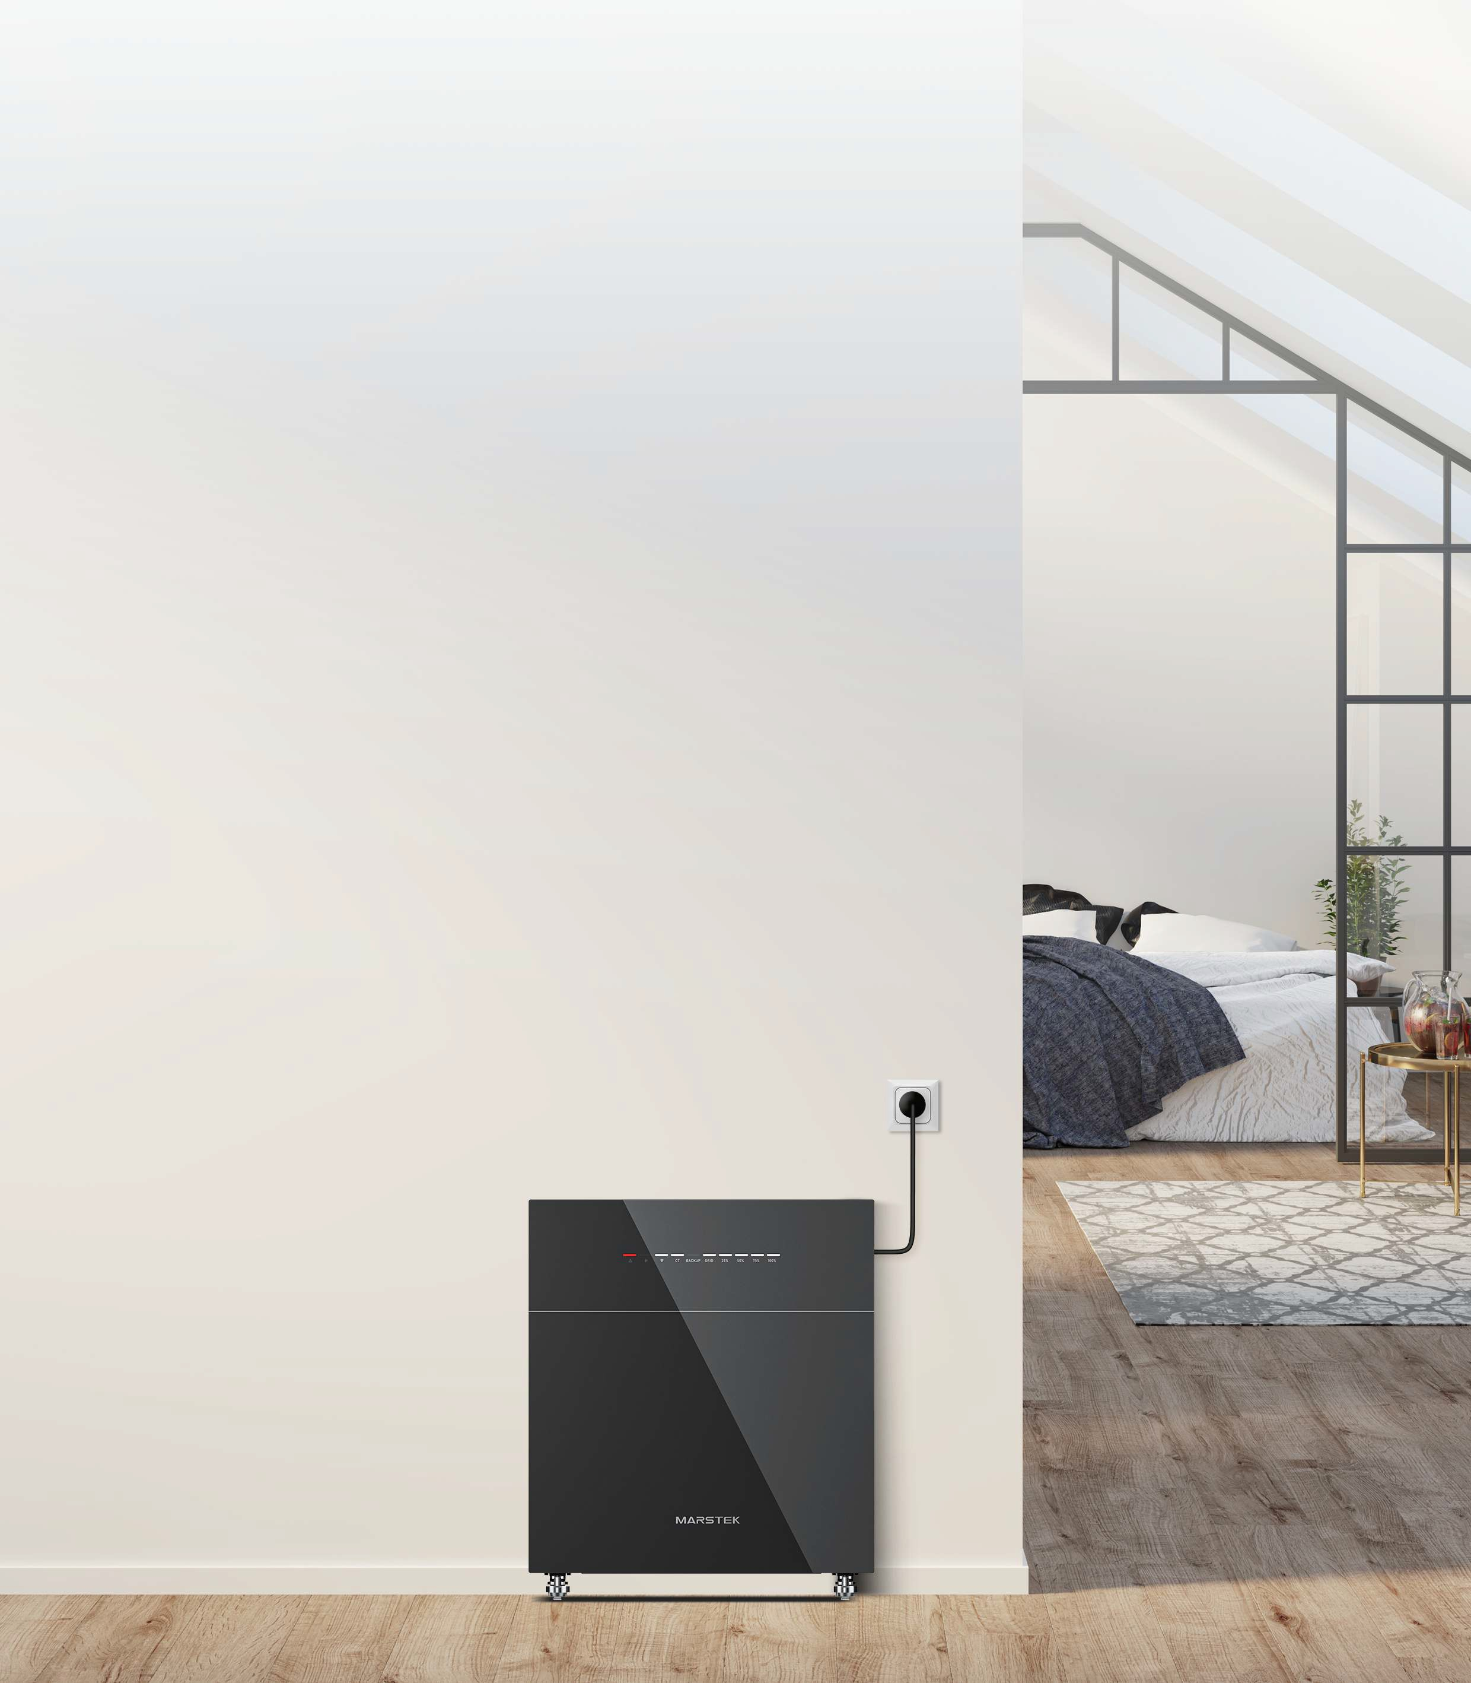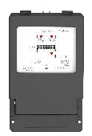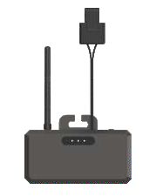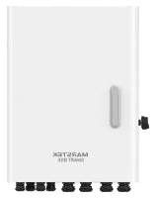100 % Self-consumption Guaranteed

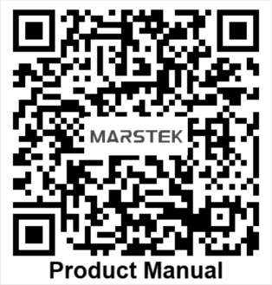
Marstek Energy Co., Limited
Add: BLDG#A, Changfang Industrial Park, No.2 Guihua 5th Road, Pingshan District, Shenzhen, Guangdong, China Tel: 86-755-28398778 Email: market@marstekenergy.com Web: www.marstekenergy.com

SPECIFICATIONS
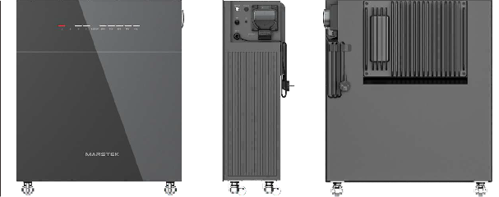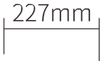
_J_
600mm
E
.^{E},.
N
r-

Model | VENUS-E
Rated Voltage | 51.2V(l6S)
Capacity | 5120Wh
Life Cycle (Times) | >6000 (25'C)
Battery Type | LiFePO,
DoD | 90%
Current | 60A
Rated Input/ Output Power | 2.5kW
Operating Phase | L / N / PE
Rated Grid Voltage | 220V / 230V
Grid Voltage Range | 187V~253V
Rated Grid Frequency | 50Hz / 60Hz
Rated Grid Input/Output Current | 11.4A / 10.9A
Max. Input/Output Current | 13.4A
Power Factor | > 0.99 (Default)/ 0.8 leading~0.8 lagging (Adjustable)
THDi | <3%
Rated Off-grid Output Power | 2.5kW
Max. Apparent Output Power | 2.5kVA
Max. Output Current | 11.3A
Rated Output Voltage | 220V
Rated Output Voltage Freq. | 50Hz/60Hz
THDu (Linear Load) | <3%
Battery-AC Side Max. Efficiency | >93.5%
Protection Levei
Overvoltage/Voltage Withstand Levei | DC li/ AC III
lsolation Type | Non-lsolated
Operating Temperature Range | -20'C~ +60'C
Ralative Humidity | 0-95%
lngress Protection | IP65
Cooling Strategy | Natural Convection
Max. Operating Altitude | 2000m
On-grid Connection Standard | VDE 4105/0124,TOR R25, NF EN50549-10,Cl0/110,UNE217001/217002,NTS 631,CEI0-21,PETREE,PN-EN 50549-1/-2
Regulatory/EMC | IEC/EN 62109-1/-2,IEC/EN 61000-6-1/-2-/3-/4,IEC/EN 61000-3-2/-3,EN 300 328,EN 301489-1/-17,  EN 50665,EN 62920,CB 62619, EN 50549-1
Dimension | 600*742*227mm
Weight | 60±0.Skg
On-grid AC Connection | Three-wire Household Plug (Eurol6A)
Display | LED
Supported Communication lnterface | WIFI & RS485 (Waterproof aviation plug)

